Balloon Racers

j0212957



We have been learning about forces and motion in science. Now it is time to experiment! Your job is to create a Balloon Racer Car. Follow the guidelines below to make your creation.

Guidelines:

1. The car MUST be powered by balloons. (Keep it small – around 12” x 12” at a maximum. Should be easily carried by **YOU** on the bus or car.)
2. You can build the car out of anything. **(Reduce, Reuse, And Recycle!!)**
3. It must have at **least three wheels**. Wheels are defined as anything that is round and goes around.
4. The wheels ***CAN NOT be wheels from a toy car***. They must be made out of something that was not originally meant to be wheels.
5. The car may not leave the ground.
6. The car must be capable of traveling at least **24 inches.**
7. Written portion will be completed in science class.

You will be given a grade based on your participation in the race and completion of your Balloon Racer:

|  |  |
| --- | --- |
| Balloon Racer completed on time. (Homework) | /20 |
| Followed guidelines for building racer. (Homework) | /30 |
| Car traveled at least 24 inches. | /15 |
| Written portion: clear explanation of how friction, gravity, force, and kinetic & potential energy relate to the motion of your car. | /35 |
| Total Points | /100 |

Race day is __________________. Good luck!!

(See examples on back for some ideas.)

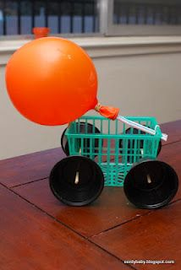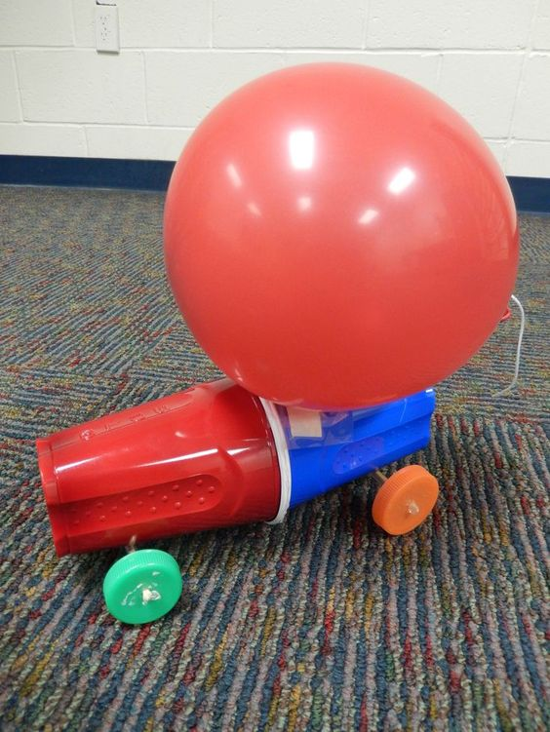

Examples of balloon racers