Topic 10 Math Study Guide
Test Date: Thurs, Feb 1, 2018

On your test, you will be expected to:

- Understand meanings of fractions – what does the denominator tell you? What does the numerator tell you?

- Recognize and solve for equivalent fractions
  - Example: 4/5 is equivalent to 8/10

- Recognize and write fractions in simplest form
  - Example: 10/20 in simplest form is 1/2

- Use a number line to find equivalent fractions
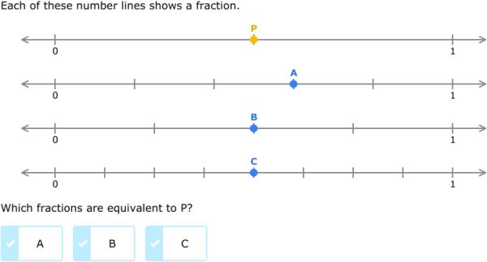
- Compare fractions (<, >, =)

- Solve word problems involving fractions.

