Topic 15 Math Study Guide
Test Date: Friday, April 13, 2018

On your test, you will be expected to:

- Organize data into a frequency table and use it to answer questions.

Example:
Shoe size | Tally | frequency
4 | l | 1
5 | ll | 2
6 | llll | 4
7 | l | 1

“Which shoe size occurred most frequently?”

- Organize data into a dot plot and use the dot plot to solve problems.

Example:
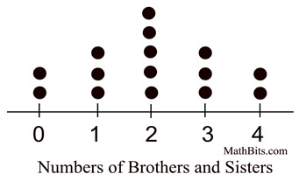

“How many more children had two siblings than one sibling??”

- Use the tens place to organize a set of data into a Stem-and-Leaf Plot and use it to answer questions.

Example:
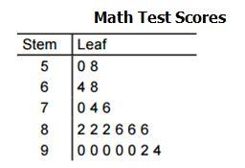

“How many students scored in the 80s on this test?”

